Hackathon 1
2a) Data Types:
Write a Java program to store and display the following details of a rooftop solar system:
Panel ID – integer
Energy generated in kWh – decimal value
Number of solar panels – integer
System status – character
Use appropriate Java data types for each value and display all the details.

Code :
import java.util.Scanner ;
public class Solartype {
public static void main(String[] args) {
int PanelId=25 ;
double Energygenerated = 8.5 ;
int NumberofSolarPanels= 12 ;
char Systemstatus ='R' ;
System.out.println(" Rooftop Solar System Details ");
System.out.println(" PanelID :" + PanelId );
System.out.println("Energy generated in KWh =" + Energygenerated);
System.out.println("Number of Solar Panels = "+NumberofSolarPanels);
System.out.println("System status ="+ Systemstatus);
}
}
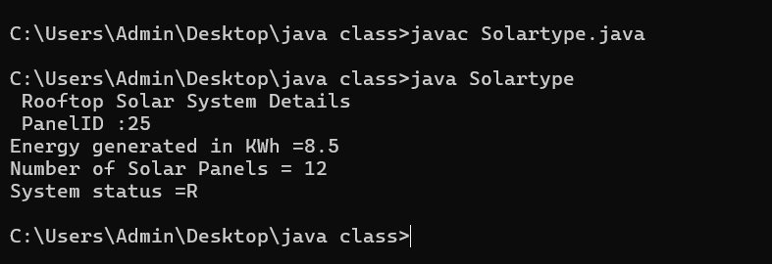

2b) If-Else Condition:
Write a Java program to monitor the energy generated by a rooftop solar system. Read the energy generated in kWh.
- If the energy generated is 10 kWh or more, display "Good Energy Generation".
- Otherwise, display "Low Energy Generation".
Use an if-else statement.

Code:
import java.util.Scanner ;
public class SolarEnergy_1 {
public static void main(String[] args) {
System.out.println(" Enter Energy Generated in kWh");
Scanner sc =new Scanner (System.in);
int EnergygeneratedinkWh = sc.nextInt();
if (EnergygeneratedinkWh >=10)
{
System.out.println("Good Energy Generation");
}
else {
System.out.println("Low Energy Generation");
}
}
}

Output :

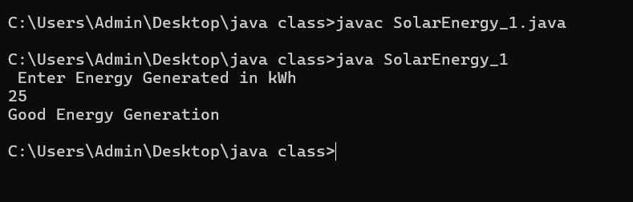

2c) Methods:
Write a Java program to calculate the total energy generated by a rooftop solar system using a method.
Create the following method:
calculateTotalEnergy(double morningEnergy, double eveningEnergy)
The method should return the total energy generated. Read the morning and evening energy generation values from the user, call the method, and display the total energy generated.
Answer:(penalty regime: 0, 0, ... %)

Code:
import java.util.Scanner;

public class Solarwind {

public static double getTotal(double morning, double evening) {
return morning + evening;
}
public static void main(String[] args) {
Scanner sc = new Scanner(System.in);
System.out.print("Enter morning energy (kWh): ");
double morning = sc.nextDouble();
System.out.print("Enter evening energy (kWh): ");
double evening = sc.nextDouble();
double total = getTotal(morning, evening);
System.out.println("Total energy generated: " + total + " kWh");
sc.close();
}
}

Output :

